Good morning, children.

Dnes si znovu společně zopakujeme sloveso CAN a CAN ´ T.

1. Doplň chybějící slovo

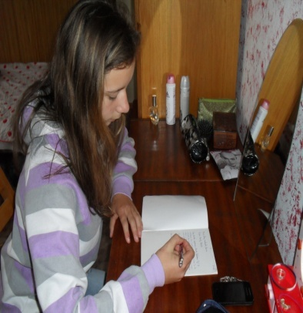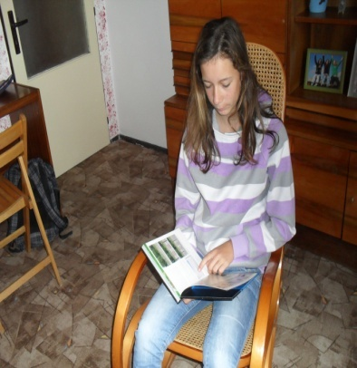

1. 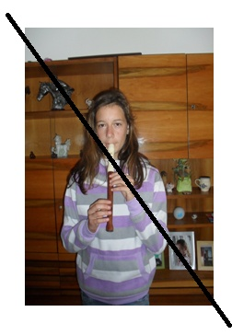She can ……………………. 2. She can ………………………

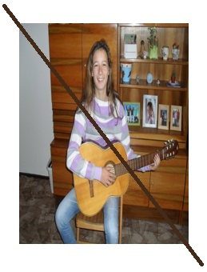

3. She can´t …………. the guitar. 4. She can´t play ……………….

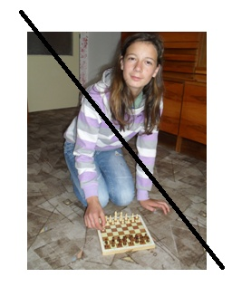

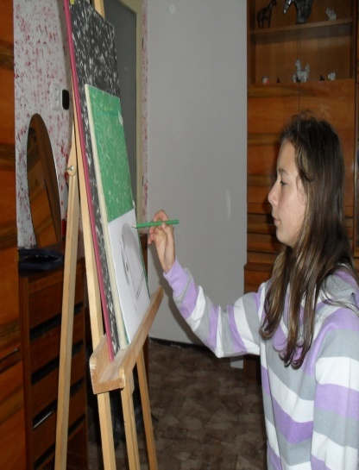

5. She can ………….. 6.She can´t …………… chess.

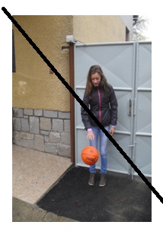

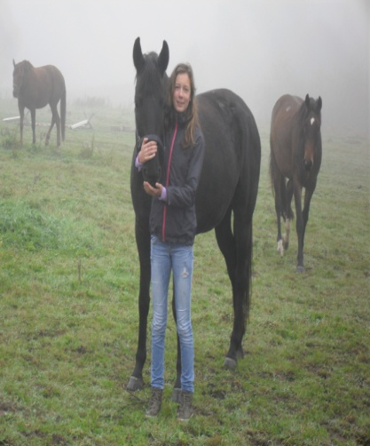

7. She …………………… play basketball. 8. She can ……….... a horse.

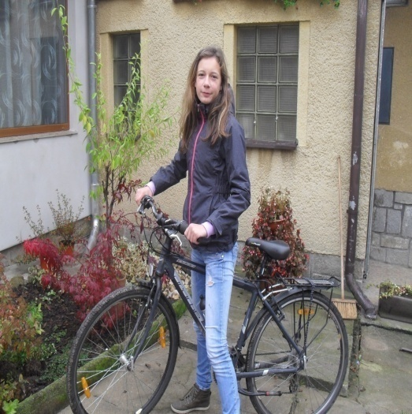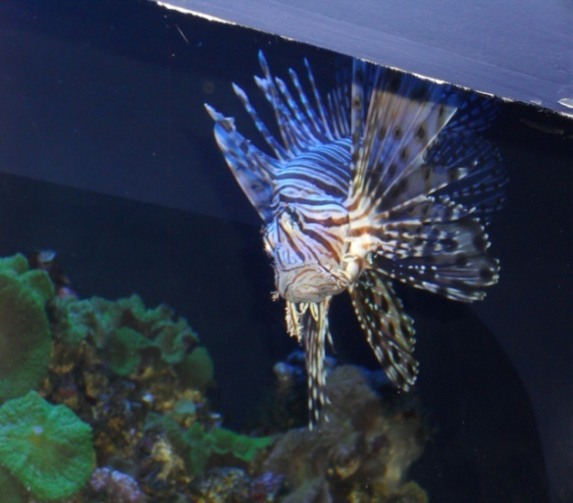

9. It can ………………… 10. She ………………….. ride a bike.

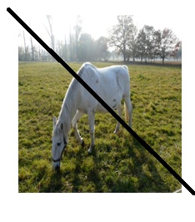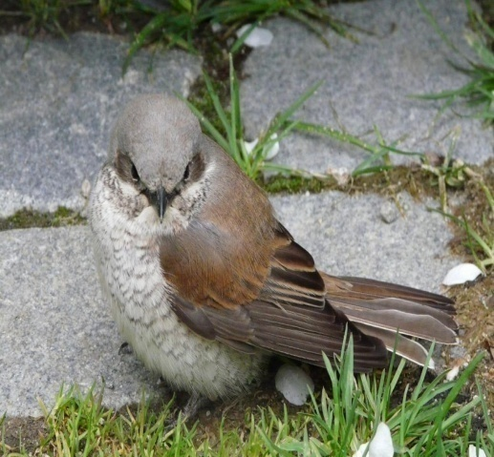

11. It ………………..fly. 12. It can …………………….

II. Spoj čarou zvíře s tím, co může umět

fish fly

monkey run fast

horse jump

bird swim

III. Čti o Tomovi

Hello, my name is Tom. I am ten. I have got one brother and one sister. I live in a small village. I like sports. I can run very fast. I can jump, I can play football and basketball. I don´t like music. I can´t play any musical instrument. I can´t sing and dance. I can draw, but I can´t ski. I can swim very good.

IV. Odpověz na otázky

1. How old is he? ………………………………..
2. Where does he live? ……………………………….
3. Can he run fast? ……………………………….
4. Can he dance? ……………………………….
5. Can he play the piano? ……………………………….
6. Can he swim? ……………………………….
7. Can he sing? ………………………………
8. Can he play basketball? ………………………………
9. Can he draw? ………………………………
10. Can he ski? ………………………………

V. Odpověz podle sebe, zakroužkuj vyhovující odpověď

1. Can you swim? Yes, I can. No, I can´t.
2. Can you sing? Yes, I can. No, I can´t.
3. Can you speak English? Yes, I can. No, I can´t.
4. Can you run fast? Yes, I can. No, I can´t.

VI. Přelož

1. Lucy neumí bruslit.___________________________________
2. John umí běhat.______________________________________
3. Umí oni zpívat?______________________________________
4. Joe neumí skákat._____________________________________
5. Umíš ty hrát golf?_______________________________________
6. Ann umí tančit._______________________________________

VII. Hledej a škrtej slova, která označují, co umí moje neteř nebo zvířata na fotografiích.

|  |  |  |  |  |  |
| --- | --- | --- | --- | --- | --- |
| B | W | R | E | A | D |
| A | R | U | S | P | R |
| S | I | N | G | L | A |
| W | T | K | E | A | w |
| I | E | T | B | Y | A |
| M | F | L | Y | L | L |

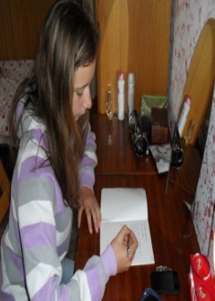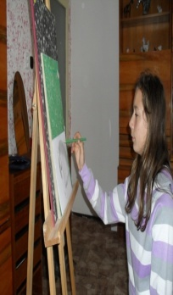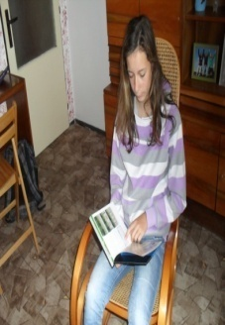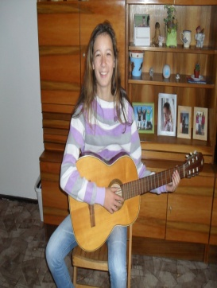

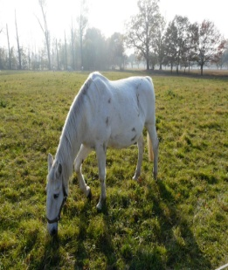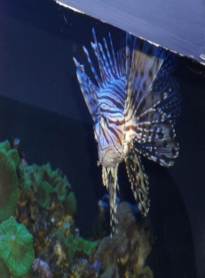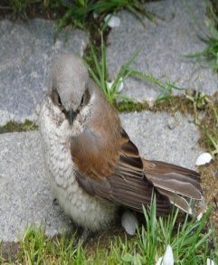 zpívat a hrát

Po vyškrtání sloves můžeš po řádcích přečíst slovo, které označuje sport.

Napiš ho:_________________________________

Můžete s zazpívat:

<https://www.youtube.com/watch?v=_Ir0Mc6Qilo>

<https://www.youtube.com/watch?v=iBceWhZZXBc>

Have a nice day. Good bye.